 | ALL SAINTS’ COLLEGE  Ewing Avenue, Bull Creek, Western Australia
 | HUMAN BIOLOGY

Year 11 2006 - Semester I Examination - Question/Answer Booklet
C.C. STUDENT NUMBER - In figures 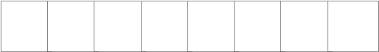

TIME ALLOWED FOR THIS PAPER
Reading time before commencing work: Ten minutes
Working time for paper: Two hours thirty minutes

MATERIAL REQUIRED/RECOMMENDED FOR THIS PAPER
TO BE PROVIDED BY THE SUPERVISOR
This Question/Answer Booklet
Standard Answer Booklet
Multiple Choice Answer Sheet

TO BE PROVIDED BY THE CANDIDATE
Standard Items: Pens, pencils, eraser and ruler.
Special Items: A 2B, B or HB pencil for the separate Multiple Choice Answer Sheet and calculators satisfying the conditions set by the Curriculum Council.

INSTRUCTIONS TO CANDIDATES

See page 2.

No other items may be taken into the examination room.
It is your responsibility to ensure that you do not have any unauthorised notes or other items of a non-personal nature in the examination room. If you have any unauthorised material with you hand it to the supervisor BEFORE reading any further.

STRUCTURE OF THIS PAPER

Part | No. of questions  available | No. of questions to be attempted | Marks available
I Multiple Choice  II Diagram and Short Answer questions  III Extended answer questions: | 40  12  2 | ALL  ALL  1 | 80  80  20

Total Marks = 180 → 100%

INSTRUCTIONS TO CANDIDATES

PART I Should be answered on the separate Multiple Choice Answer Sheet. Use a 2B, B or HB pencil, NOT A BALL POINT OR INK PEN.

PART II Should be answered in this Question/Answer Booklet. Write your answers in the spaces provided, using a blue or black ballpoint or ink pen. Draw any diagrams in pencil.

PART III Should be answered in the Standard Answer Booklet, using blue or black ballpoint or ink pen.

Make sure your Curriculum Council Student Number is on your Multiple Choice Answer Sheet, this Question/Answer Booklet and the Extended Answer Booklet.

PART I: Multiple Choice (80 Marks)

Suggested time: 50 minutes.
Mark your answers to Questions 1 – 40 on the SEPARATE MULTIPLE CHOICE ANSWER SHEET, using a 2B, B or HB pencil. If you make an error, follow the instructions given to you on your answer sheet.

1. Skeletal muscle is
- smooth, involuntary and multinucleate.
- smooth, voluntary and uninucleate.
- striated, voluntary and multinucleate.
- striated, involuntary and uninucleate.

2. The list below gives some characteristics of the Families Hominidae (man) and Pongidae (ape).

I Stereoscopic vision
II Opposable big toes
III Opposable thumbs
IV Presence of premolar and molar teeth
V Jaw shape

Which characteristics taken together can be used to distinguish between the two families?
- I and IV.
- II and V.
- I and III.
- I, IV and V.

3. Digestive enzymes

- are present in saliva but not in gastric juice
- are needed to break down starch and water
- are not present in bile
- include lipase, protease and citric acid

4. Sutures represent a type of joint called
- synovial.
- immovable.
- pivot.
- gliding.

Questions 5 and 6 are based on the following information.
Eucalyptus Oil (EO) is believed to prevent colds. To test this belief 20 000 volunteers were placed in four groups and each individual took a dose every morning for one year.
Volunteer group | No. in group | Contents of dose | Number in group who Developed a cold.
1 | 4 750 | 5 grams of sugar | 20
2 | 4 750 | 5 grams of sugar + 1 gram EO | 19
3 | 4 750 | 5 grams of sugar + 3 grams EO | 21
4 | 4 750 | 5 grams of sugar + 9 grams EO | 10

- Which group served as the control for this experiment?

  - 1.
  - 2.
  - 3.
  - 4.

- From the results of this experiment we can conclude that:

  - Sugar reduced the number of colds.
  - Sugar increased the number of colds.
  - Sugar + 3 grams or less of EO proved effective in the prevention of colds.
  - 9 grams of EO is effective against colds.

7. Which of the following is the correct path taken by air during inspiration?
- Larynx, trachea, nasal cavity, bronchi, bronchioles, alveoli.
- Larynx, nasal cavity, bronchi, trachea, bronchioles, alveoli.
- Nasal cavity, larynx, trachea, bronchi, bronchioles, alveoli.
- Nasal cavity, trachea, larynx, bronchioles, bronchi, alveoli.

8. Which of the following when added to the diet would do most to improve night vision

- Vitamin A
- Lemon Juice
- Calcium
- Increased protein

9. Consider the following diagram which represents a magnified view of human tissue with a capillary network.
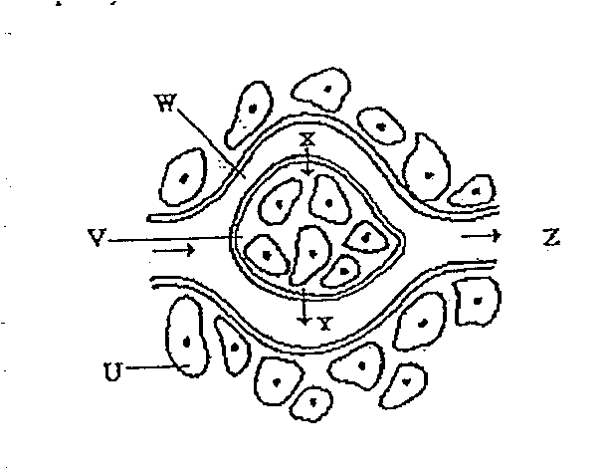
You could reasonably say
- arrow Y represents movement of glucose.
- arrow X represents movement of oxygen.
- region V represents plasma.
- region Z represents an area low in metabolic wastes.

10. The following graph shows the effect that the concentration of substrate (substances on which an enzyme acts) has on the rate of an enzyme-mediated reaction.

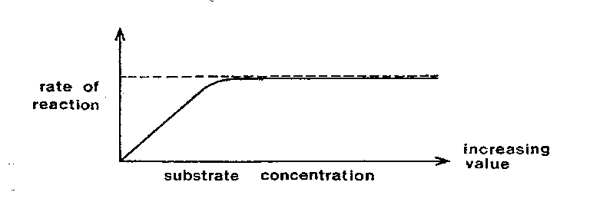

The graph indicates that
- the higher the concentration of the substrate the greater the rate of reaction.
- the rate of reaction is unaffected by the substrate concentration.
- above a certain concentration, increased levels of substrate have no effect on the rate of reaction.
- above a certain concentration, the rate of reaction is decreased by increased levels of substrate.

11. Bones form a useful reserve (for the body) of
- calcium and phosphorous.
- calcium and potassium.
- calcium and magnesium.
- calcium and iron.

12. The process by which a bone cell surrounds itself with a hard matrix of mineral salts and fibres is known as

- canaliculi.
- metaphysis.
- fusing.
- ossification.

Questions 13 and 14 refer to the following information.
A number of characteristics are possessed by humans. Use this list as the key to answer the next two questions.
I Opposability of first digit
II Large brain in proportion to body size
III Hollow dorsal nerve cord
IV Hair

13. Which of the characteristics indicate that Man is a primate?
- I and II.
- All of them.
- I, II and III.
- IV.

14. Which of the characteristics indicate that Man is a Chordate?
- I.
- II.
- III.
- IV.

15. The correct way to represent humans' biological name is
- Homo Sapiens.
- homo sapiens.
- Homo sapiens.
- Homo Sapiens.

16. Each protein is made up of many amino acids. Different proteins differ in
- the total number of amino acids.
- the proportions of different amino acids.
- the order in which amino acids are arranged.
- all of the above features.

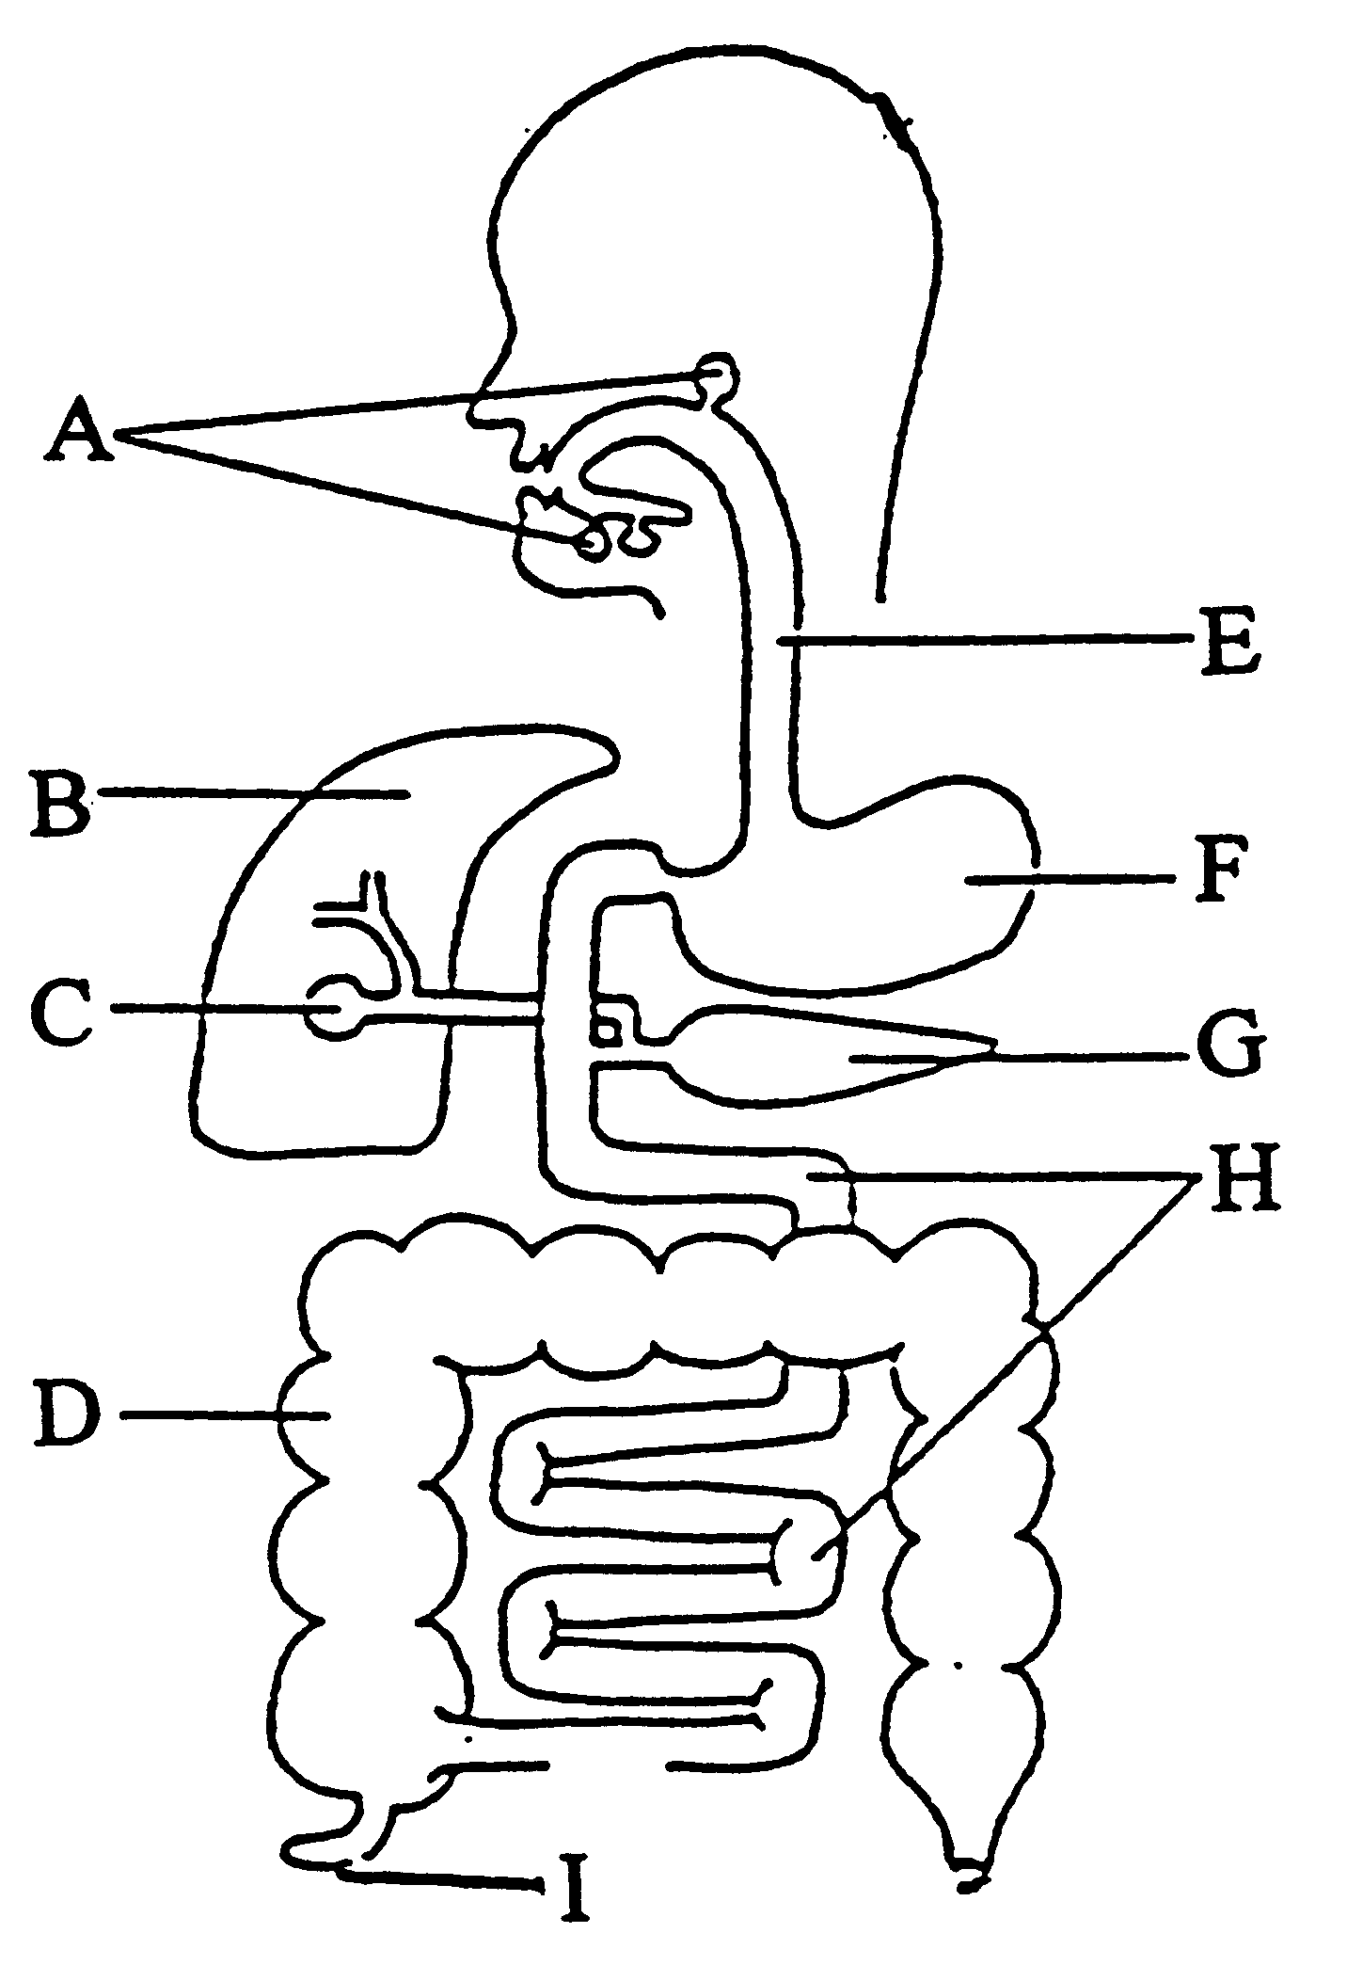
Use the diagram shown above to answer the next two questions.

17. Which structure is responsible for water absorption from undigested food?

- D
- F
- G
- I

18. Structures A G and I are

- all accessory glands
- parts of the gut where fluid is added to the contents
- the salivary glands, the pancreatic duct and the ascending colon respectively
- the salivary glands, the pancreas and the appendix respectively

19. The axial skeleton is composed of
- arms, legs and associated girdles.
- arms and legs only.
- vertebra, skull and sternum.
- vertebra, skull and ribs.

- A 65-year-old man suffers a near fatal heart attack that damages the papillary muscle in his left ventricle. The heart attack is most likely to cause which heart valve to become non-functional?

  - Tricuspid or the right atrioventricular valve.
  - Pulmonary valve.
  - Mitral or bicuspid or left atrioventricular valve.
  - Aortic valve.

Question 21 refers to the diagrams below.

Position A Position B

Positions of the right lower limb. Upright standing position (A) and after raising the right root from the ground (B).

21. The movements of the right lower limb which have occurred in moving from position (A) to position (B) include

- flexion at the hip and flexion at the knee.
- flexion at the hip and extension at the knee.
- extension at the hip and flexion at the knee.
- extension at the hip and extension at the knee.
22. Humans and pongids are classified into the same family. This means that they would be classified in

- the same phylum but different class.
- the same class but different species.
- a different kingdom and different phylum.
- the same genus but different phylum.

23. Spongy bone is
- is mainly found in the diaphysis.
- has cells arranged in a circular pattern.
- has blood vessels found in the many spaces.
- acts as a shock absorber.

24. The pancreas secretes the following substances EXCEPT
- Hydrogen carbonate ions.
- proteases.
- lipase.
- cholesterol salts.

25. Choose the correct function for these labelled parts of the bone.
- D would give strength to the bone.
- F would reduce friction.
- G is where blood cells are formed.
- E is a protection membrane.

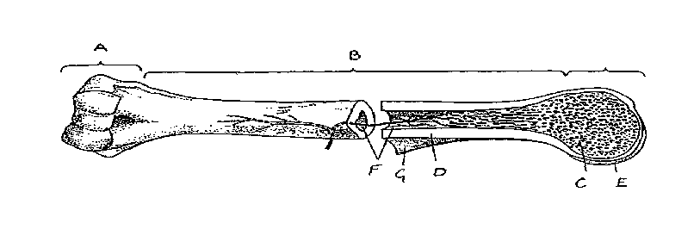

26. A person has damaged their arm by falling from a bike. The following symptoms are present. Pain of the lower arm, distortion of the forearm, swelling which is particularly bad a third of the way from the wrist to the elbow and loss of movement of fingers.

Which of the following treatment programmes should you follow?
- Follow R.I.C.E. procedure. Apply rest, ice, compression and elevation.
- Place arm in a comfortable position so patient can rest it, then apply ice for 10
minutes, bandage firmly and seek medical help.
- Leave the person with arm in comfortable position, after R.I.C.E. treatment,
wait for 2 days to see if swelling is reduced.
- Place arm in a comfortable position, bandage to a splint, place in a sling and
seek medical help.

27. Which of the following primates would NOT be included in the classification group Anthropoid?
- Lemur.
- Gibbon.
- New World Monkey.
- Baboon.

28. A student was given four powders W, X, Y and Z. Each powder was tested for the
Glucose – using Benedict's test
Starch – using the iodine test
Protein – using the Sakaguchi test
The table of results below shows the final colour observed at the end of each of the tests.

 | Powder W | Powder X | Powder Y | Powder Z
Benedict's test | orange | blue | blue | orange
Iodine test | black | black | yellow/brown | black
Sakaguchi test | blue | blue | purple | purple

Which powder contained starch and glucose only?
- W
- X
- Y
- Z.

29. Severe haemorrhage is dangerous primarily because
- There is a danger of entry of disease organisms through the wound while the person is bleeding heavily.
- A large drop in blood volume occurs.
- Red blood cells are irreplaceably lost.
- Air bubbles can enter the blood stream.

30. Brachiation means
- using the limbs to grasp objects.
- five digits on each limb.
- a clinging and climbing action.
- using the forelimbs to swing from branch to branch.

31. To test the effectiveness of a new drug designed to treat bone cancer, a researcher selected 47 bone cancer patients. During the three year trial period about half of the patients were to be given the new drug while the remainder were to be treated by conventional therapy. Selection of the patients for treatment with the new drug was to be at random.

In the experiment described above, the independent variable is the:
- 47 bone cancer patients.
- random selection of the patients for the type of treatment.
- type of treatment given to the patients.
- effect of the treatment on the bone cancer.

32. A limb terminating in 5 digits is
- brachial.
- opposable.
- pentadactyl.
- dipedal.

33. The following arteries originate from the aorta. Identify the most SUPERIOR artery.
- Hepatic artery.
- Femoral artery.
- Renal artery.
- Carotid artery.

34. Which of the following skeletal features enhance bipedalism?
- The heel bone is small.
- The pelvis is narrow and long.
- The femur bones are long.
- The foramen magnum is located towards the back of the skull.

- The removal of undigested food through the anus is called..

  - excretion
  - elimination
  - assimilation
  - egestion

36. The double layered ‘sac’ that encloses the heart is called the
- Myocardium.
- Pericardium.
- Endocardium.
- Pleural membranes.

37. Muscular tone is
- when a proportion of the fibres in opposing muscles remain contracted to hold the body in position.
- a complete, continuous contraction of a muscle.
- a spasmodic contraction of skeletal muscle.
- stiffness of a muscle brought about by unusual exercise.

38. Which of the following correctly compares the blood in the pulmonary arteries to the blood in the aorta?

- The blood in both vessels has low concentrations of oxyhaemoglobin.
- The blood in both vessels has a high concentration of oxyhaemoglobin.
- The blood in the pulmonary arteries has less oxyhaemoglobin than the blood
in the aorta.
- The blood in the pulmonary arteries has more oxyhaemoglobin than the blood
in the aorta.

39. Compared to inhaled air, exhaled air should contain a higher percentage of
- oxygen, carbon dioxide and water vapour.
- nitrogen, carbon dioxide and oxygen.
- carbon dioxide and nitrogen.
- carbon dioxide and water vapour.

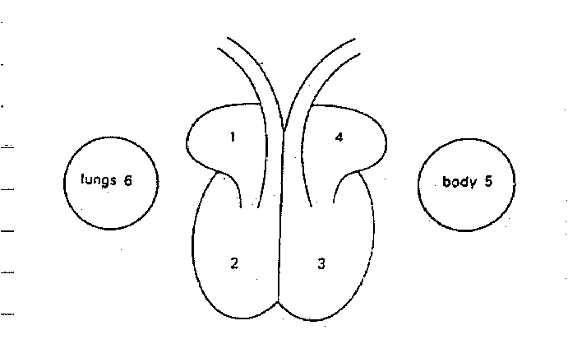40. Select the correct sequence of blood flowing through the heart commencing with the left ventricle shown in the diagram on the right.

- 4, 3, 2, 6, 1, 5.
- 4, 3, 6, 1, 2, 5.
- 3, 5, 1, 2, 6, 4.
- 3, 5, 6, 4, 2, 1.

PART II: Diagram and Short Answer (80 Marks)
Suggested time: 70 Minutes
Write answers to ALL questions on the lines after each question or in the spaces provided.
Write your answers in blue or black ballpoint or ink pen. Draw diagrams in pencil.

41. (12 Marks)
A research group found that the drug, ‘LBP’, when administered intravenously, increased the depth of breathing in patients suffering from asthma. In response to patients who disliked injections, a new formulation of LBP was developed which could be administered as an inhalant. Six people were used in the study, one group of three were given the injection and another group of three were given the inhalant.

(a) What hypothesis was the student testing? (1m)
_________________________________________________________________

(b)What was independent variable? (1m)
_________________________________________________________________

(c) (i) Describe how they would have set up the control in this investigation. (1m)

___________________________________________________________________________

___________________________________________________________________________

(ii) What is the purpose of setting up a control? (2m)

__________________________________________________________________________

__________________________________________________________________________

(d) In the space below, draw a suitable table that could be used to record the data. Include only given information. Do not make up the values, just leave blanks if you have the data. (3m)

(e) Explain what would have been done to ensure that the results obtained were valid. (1m)

___________________________________________________________________________

- Based on your knowledge of scientific method, describe how the reliability of this investigation could have been improved. (1m)

__________________________________________________________________________

(h) State 2 points you need to remember when writing the method for an investigation. (2m)

___________________________________________________________________________

42. (5 marks)
The diagram below shows a cross-section through the chest of an adult human.
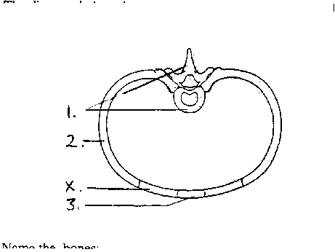

(a) Name the bones:
1.
2.
3. (3m)
(b) What type of tissue is shown at X? (1m)

(c) Label on the diagram (with the letter N) where nerve tissue would be found. (1m)
43. ( 5 marks)
(a) Describe the named stages of the cardiac cycle. (3m)
___________________________________________________________________________

___________________________________________________________________________
___________________________________________________________________________

___________________________________________________________________________

__________________________________________________________________________

(b) Describe the role/action of the semi-lunar and atrio-ventricular vales in the cardiac cycle. (2m)
___________________________________________________________________________

___________________________________________________________________________
___________________________________________________________________________

___________________________________________________________________________

44. (5 marks)
The passage below describes the process of expiration. Delete the incorrect word from each pair of words so that the passage accurately depicts the process.

During expiration the volume of the thoracic cavity increases / decreases which causes the pressure in the cavity to increase / decrease. The ribs move in and down as the external inter-costal muscles relax / contract. The diaphragm relaxes / contracts and moves up which increases / decreases the pressure in the lungs. The air moves out of the lungs.

45. (7 Marks)
Study the skull diagrams of two different primates.
Skull of Primate A Skull of Primate B
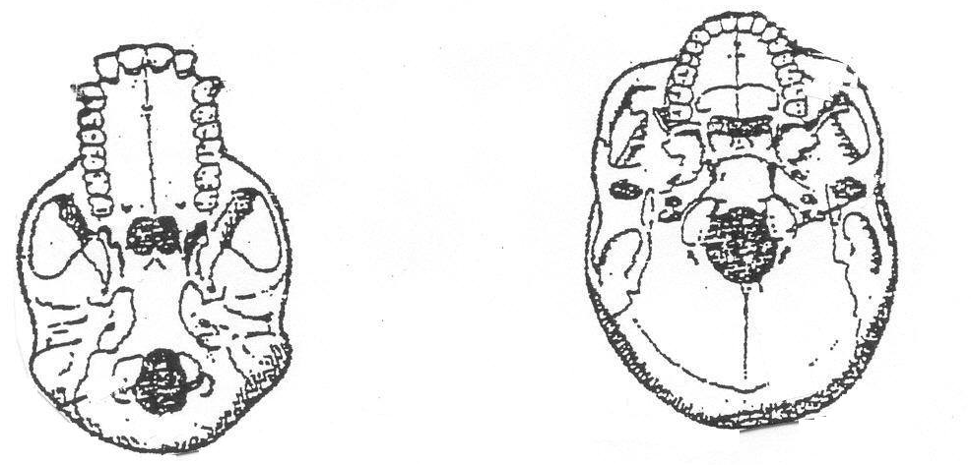
(a) Identify the families to which primates A and B belong. (2m)

A ____________________________ B ___________________________

(b) Using evidence from the skull diagrams, explain how the stance of these primates would differ. (2m)
____________________________________________________________
____________________________________________________________
____________________________________________________________
____________________________________________________________

(c) Describe two major differences in the teeth of primates A and B. (2m)
____________________________________________________________
____________________________________________________________
____________________________________________________________
____________________________________________________________

(d) State one other difference shown in the diagrams, other than those mentioned in (b) and (c) above, that could be used by anthropologists to help them identify the groups to which these primates belong.
(1m)

___________________________________________________________________________

___________________________________________________________________________

46. (6 marks)
(a) The diagram below represents part of the digestive system.

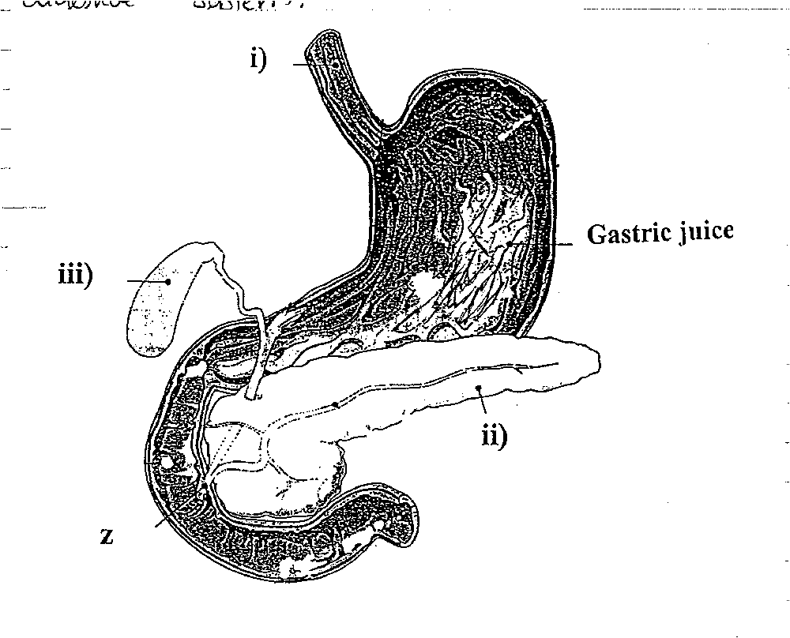
(a) Clearly label the position of the pyloric sphincter on the diagram with an ‘X’. (1m)

(b) Name the two ducts that deliver secretions at point Z. (2m)

_____________________________________________________________________

(c) Label parts (2m)
          - _____________________

          - ___________________

(d) Describe the function of the structure labelled (iii). (1m)

______________________________________________________________________

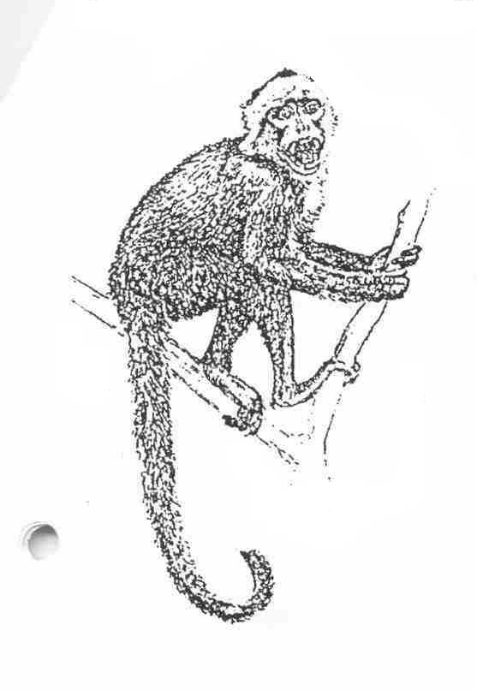47. (7marks)
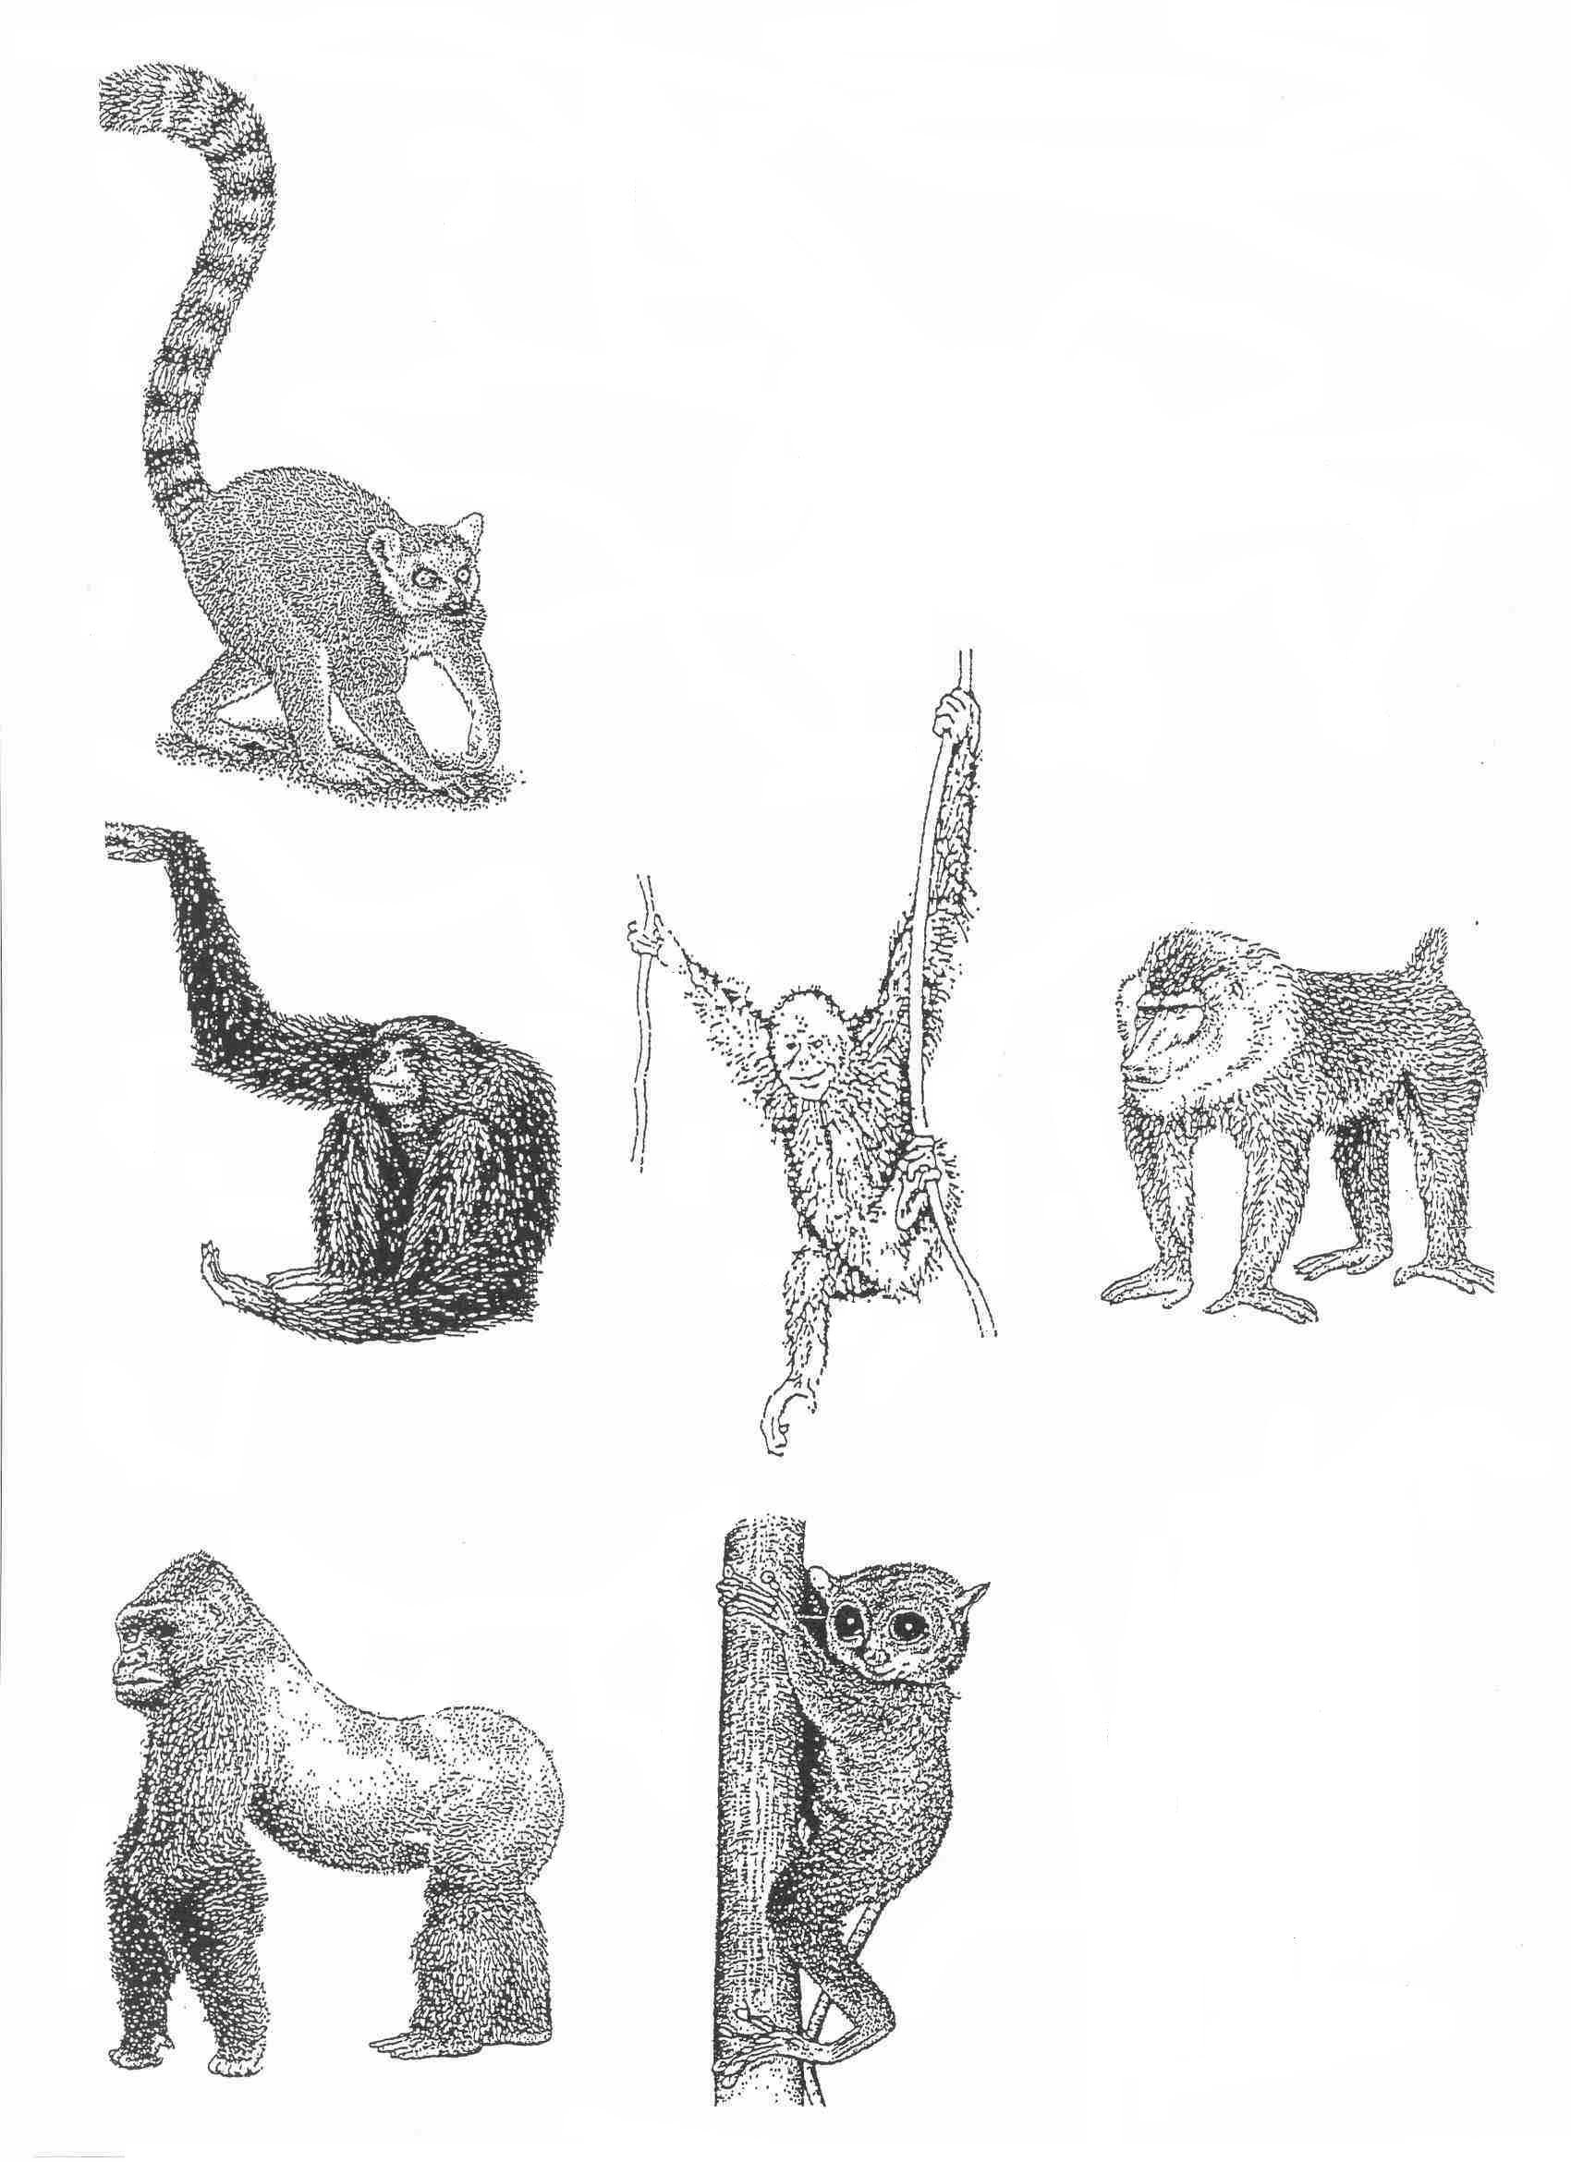
A
B
C
D
E
F
G
.
a) To what do the terms “Old World” and “New World” refer when classifying monkeys? (1m)

___________________________________________________________________________

___________________________________________________________________________

b) (i) Using the letters for the animals in the figure, give one example of a New World and an Old World Monkey. (2m)

New World Monkey _______________ Old World Monkey ______________

(ii) Clearly describe the characteristic in the figure that allowed you to make this classification. (1m)

___________________________________________________________________________

___________________________________________________________________________

c) A range of motor patterns is found in the primates in the figure. Describe the evolutionary trend for locomotion exhibited in the Primate order. Use examples from the above figure to help you in your answer. (Refer only to the letters) (3m)

___________________________________________________________________________

___________________________________________________________________________

___________________________________________________________________________
___________________________________________________________________________

48. (8 Marks)
A bowl of chocolates is placed on the table.

(a) Describe the structures and movements involved to allow you to pick up a chocolate. (4m)

__________________________________________________________________
__________________________________________________________________
__________________________________________________________________
__________________________________________________________________
__________________________________________________________________
(b) (i) Explain how the action of named muscles function to bring the chocolate up to your mouth, so you can eat it. (2m)

________________________________________________________________

________________________________________________________________

________________________________________________________________

________________________________________________________________
(b) (ii) Name this type of movement. (1m)

________________________________

(iii) Describe the position of the insertion in the muscles mentioned in (ii) above.
(1m)
_______________________________________________________________

_______________________________________________________________

49 (5 marks)

The figure below represents a mixture of two different enzymes and four kinds of complex compounds.

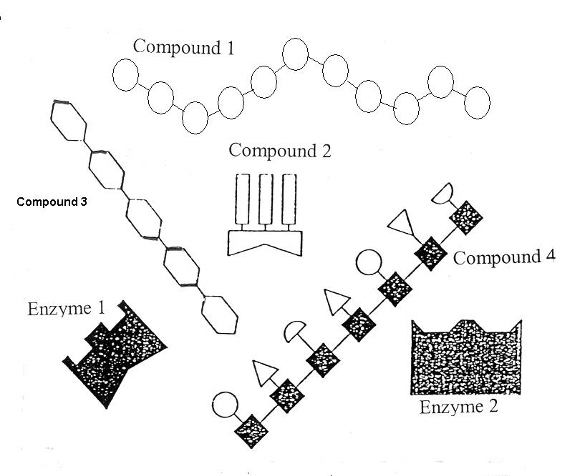

(a)Is either enzyme capable of catalysing the breakdown of the complex compounds? Explain fully. (2m)
___________________________________________________________________________

___________________________________________________________________________

___________________________________________________________________________

___________________________________________________________________________

(b) Could one of the enzymes represent bile? Explain fully. (1m)

___________________________________________________________________________

___________________________________________________________________________

(c) Sometimes a person’s gall bladder is surgically removed. What impact would this have on the person’s digestion and how might the person have to modify their eating habits? (2m)

___________________________________________________________________________

___________________________________________________________________________

___________________________________________________________________________

50. (5 marks)
(a) Even when the heart is full of blood, a person can suffer a heart attack and the
muscle is starved of oxygen.

Explain how this is possible and what happens to cause a heart attack. (3m)

_________________________________________________________________
_________________________________________________________________
_________________________________________________________________
_________________________________________________________________
_________________________________________________________________

(b) How does a stroke differ from a heart attack? (1m)

______________________________________________________________________

______________________________________________________________________

(c ) Explain how atherosclerosis can lead to cardiovascular disease. (1m)

______________________________________________________________________

______________________________________________________________________

51. (4 Marks)
The diagram below shows one of the 3 types of joints.
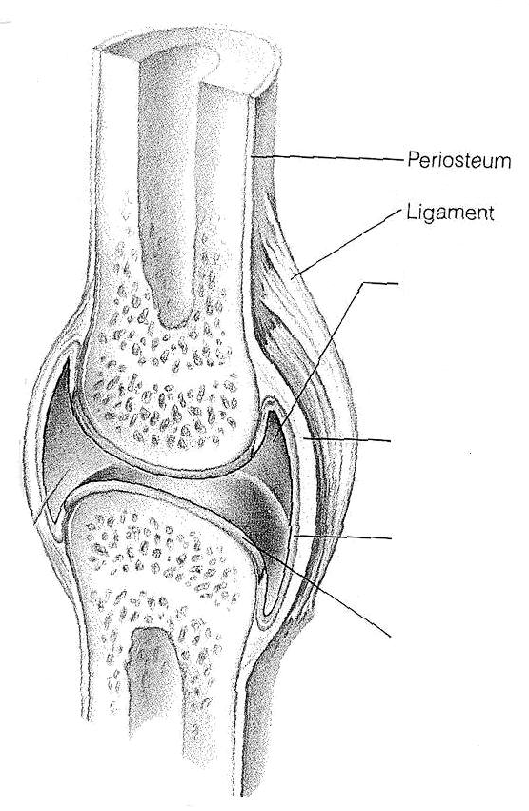

A

B

C

D

(a) Identify parts A – D. Write down the letter and the correct label alongside. (2m)

A – _________________________

B – _________________________

C – ________________________

D – ________________________

(b) Describe two functions of A. (2m)

__________________________________________________________________

__________________________________________________________________

52. (11 marks)

The diagram shows how gas exchange occurs between the alveolus and the blood.
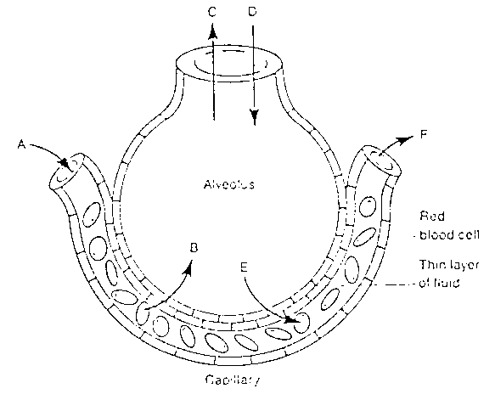

(a)Provide the correct term for the single processes indicated by

(i) arrows C and D. _______________________________

(ii) arrows B and E. _______________________________
(2m)

(b). Describe the process which moves oxygen from the alveoli into the blood capillaries
of the lung. (2m)

___________________________________________________________________________

___________________________________________________________________________
___________________________________________________________________________

___________________________________________________________________________

(c) List three ways in which carbon dioxide is transported in the blood. (3m)

____________________________________________________________________

______________________________________________________________________

(d). The diagrams below show microscopic sections of (A) healthy and (B) diseased lung tissue from adult humans.
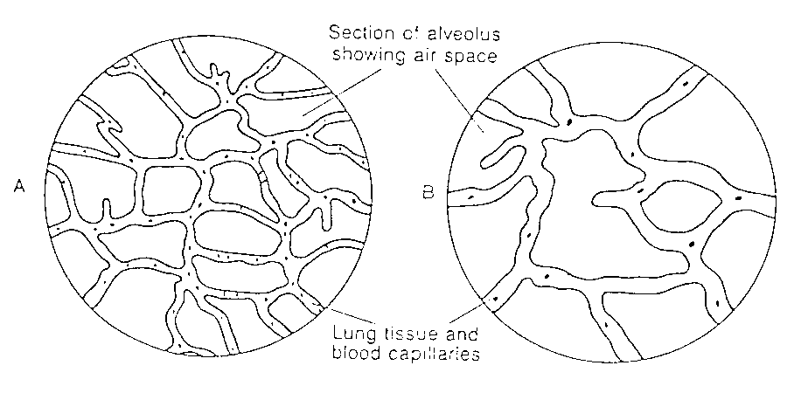

(i) Give two structural differences between the healthy and diseased lung that can be seen on the diagrams. (1m)

____________________________________________________________________

____________________________________________________________________

(ii) From your differences describe why the diseased lung would work less efficiently. (2m)

____________________________________________________________________

____________________________________________________________________

(iii) Give a possible cause of the lung damage. (1m)

____________________________________________________________________

____________________________________________________________________

PART III : Extended Answers (20 Marks)
Suggested time : 30 minutes.

Answer one question only. Illustrate your answer with diagrams where appropriate. Up to two marks may be deducted for poorly structured answers: that is, answers in point form or diagrams not explained in the text of your answers.

Remember to plan your answer and cross out your plan when you have finished using it.

DO NOT WRITE ANSWERS IN PENCIL.
Write your answers on the lined pages in your Separate Answer Booklet.
Answer either all of Question 53 or all of Question 54 – NOT BOTH.

53. i) Distinguish between the circulatory and lymphatic systems on the basis of:
- structure
- contents
- flow
- function (10)

ii) Relate the structure of arteries, veins and capillaries to their different functions
within the circulatory systems. (10)

54. i) There are three main groups of enzymes. Name each group and state
- where they are produced
- where they function in the digestive system
- which food groups or intermediate molecules they act upon
- the final products of their digestion. (17m)

ii) Enzyme activity is sensitive to a number of factors. List three factors and describe
how each one influences an enzyme’s reaction rate.
(3m)

